Assignment -3

* **Use the Employee Details dataset and perform the following activities:**

− *Split the column CITY and separate the code associate with each city like - Allahabad[AL2] should be only Allahabad and [A2] will be separate.*

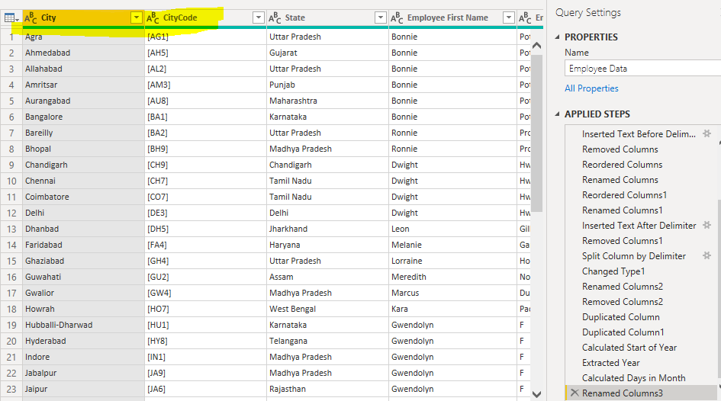

Extract the first name from EMPLOYEE NAME column and transform the column.

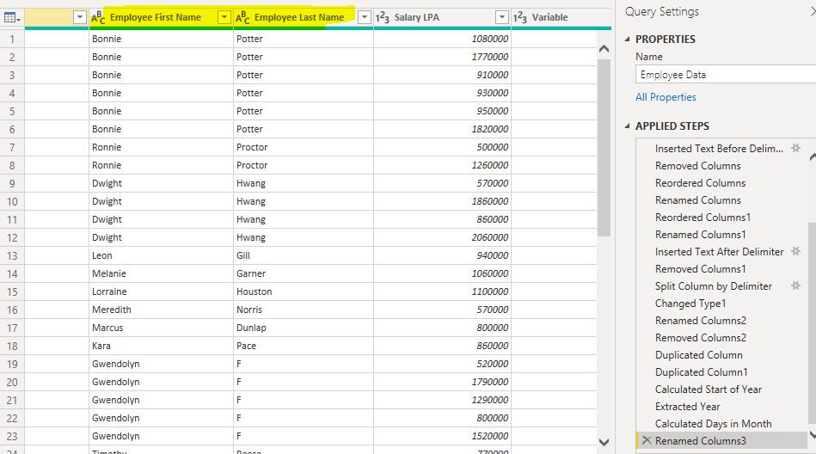

*Using the JOINING DATE column extract the Year and no. of days for that month .*

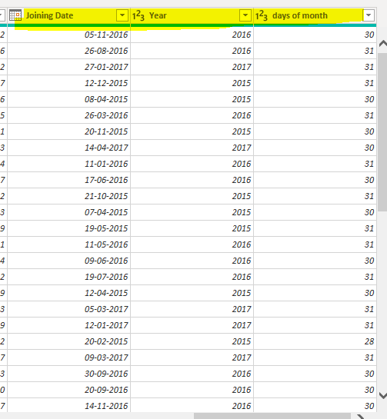

*Create a visual of your choice and show the how much salary has been paid to each state and which state has lowest payout.*

This pi chart and line chart shows the total value paid for each state among which Maharashtra has the highest paid out 🡪 13870000 state and assam and chandigarh is the lowest 🡪 570000

